What is a Graph?
A graph is a non-linear data structure consisting of:
- Vertices (nodes): Entities or points in the graph.
- Edges (links): Connections between vertices.
- Graph is network of nodes(Vertices)
Formally: A graph is denoted as G(V, E) where:
- V is the set of vertices
- E is the set of edges connecting the vertices

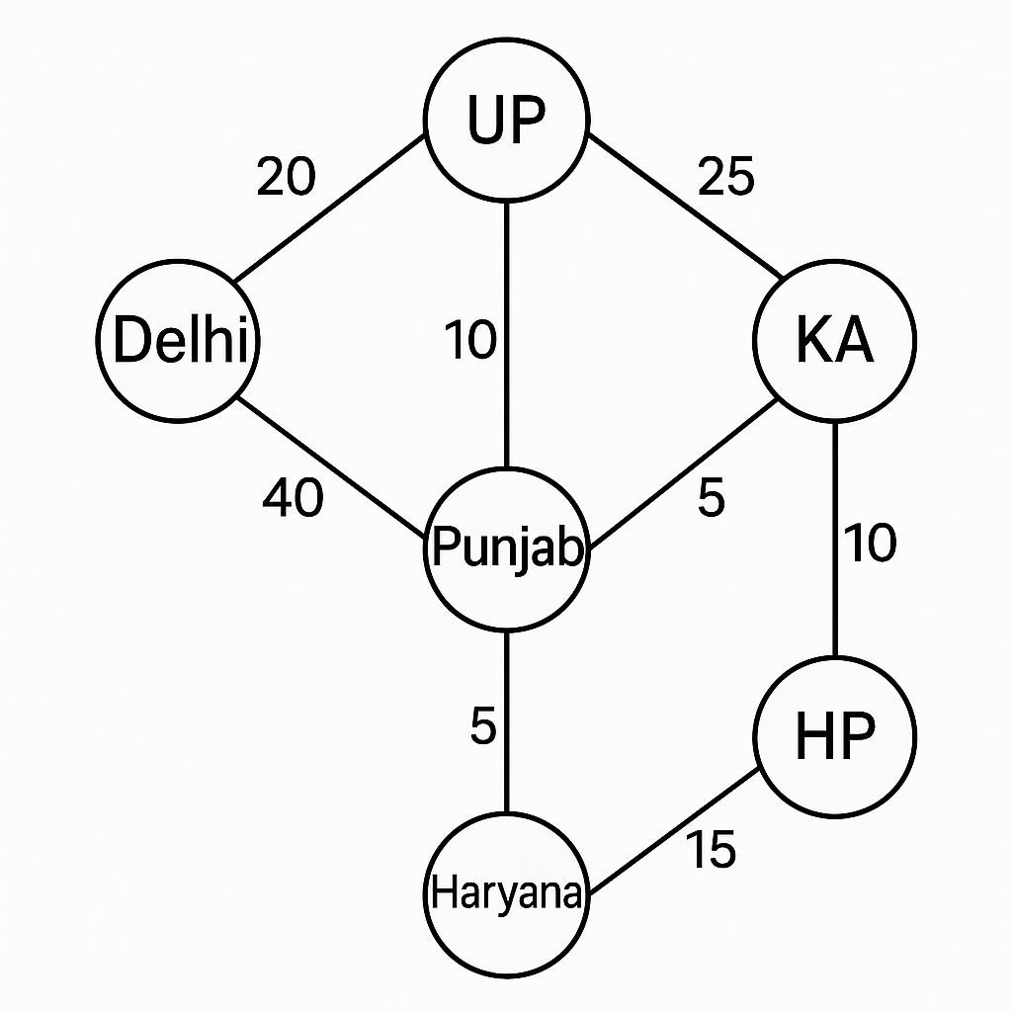
Applications of Graphs

- Maps and Navigation Systems
Real Example:
  - Google Maps, Uber, Ola, Swiggy delivery route Technical Details:
  - Vertices = Locations (cities, junctions, homes)
  - Edges = Roads between them
  - Weights = Distance or time
- Social Networks
Real Example:
  - Facebook, Instagram, LinkedIn, Twitter
Technical Details:
  - Vertices = People (users)
  - Edges = Friendships (Facebook), Followers (Twitter) • Graph Type: Undirected or directed, unweighted • Use-cases:
o Suggesting friends (Mutual connections – BFS) o Finding influencers (Centrality, PageRank) o Community detection (Clusters in the graph)
Types of Graphs Based on Edges:
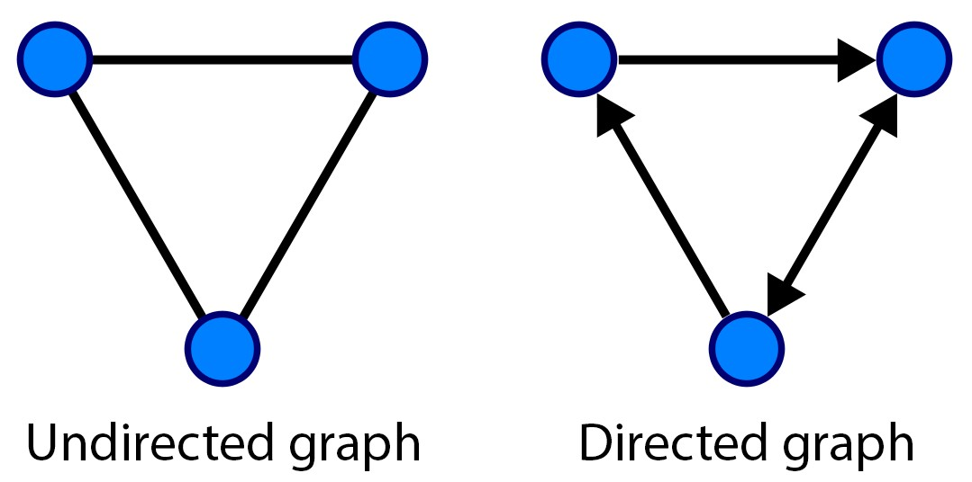
Based on Edge Weights:
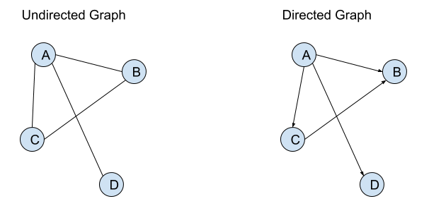
Based on Cycles:
Type Description
Cyclic Graph Contains at least one cycle
Acyclic Graph No cycles present (e.g., DAG - Directed Acyclic Graph)
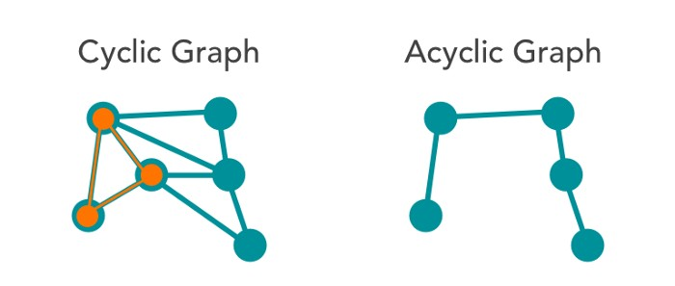

Representation

of

Graphs

in

C

There are various forms of graphs, but the more frequently used are:
    - Adjacency Matrix(2d array)
    - Adjacency List (linkedlist)

Adjacency Matrix
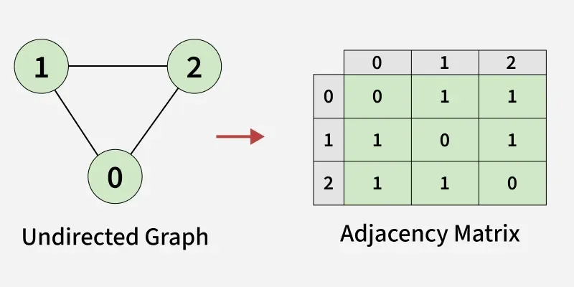
An N × N grid (matrix) that stores:
- 1 → edge exists
- 0 → edge does NOT exist
Where N = number of vertices.
Matrix position:
matrix[i][j] = 1 → means vertex i is connected to vertex j
matrix[i][j] = 0 → no connection

Example Graph
Vertices = { 0, 1, 2, 3 }
Edges:
0 — 1
0 — 2
1 — 2
2 — 3

Adjacency Matrix
 | 0 | 1 | 2 | 3
0 | 0 | 1 | 1 | 0
1 | 1 | 0 | 1 | 0
2 | 1 | 1 | 0 | 1
3 | 0 | 0 | 1 | 0

Algorithm:
1. Create matrix[n][n] and initialize all to 0
2. For each edge:
read u, v
set matrix[u][v] = 1
set matrix[v][u] = 1 // because undirected
3. Print the matrix

Program: (Undirected + Unweighted Graph using Adjacency Matrix)
#include <iostream>
using namespace std;

int main() {
int n, e;
cout << "Enter number of vertices: ";
cin >> n;

int adj[n][n] = {0}; // initialize all to 0

cout << "Enter number of edges: ";
cin >> e;

cout << "Enter edges (u v): \n";
for (int i = 0; i < e; i++) {
int u, v;
cin >> u >> v;
adj[u][v] = 1;
adj[v][u] = 1; // undirected
}

cout << "\nAdjacency Matrix:\n";
for (int i = 0; i < n; i++) {
for (int j = 0; j < n; j++) {
cout << adj[i][j] << " ";
}
cout << endl;
}

return 0;
}

Program: Directed + Unweighted Graph using Adjacency Matrix
#include <iostream>
using namespace std;

int main() {
int n, e;
cout << "Enter number of vertices: ";
cin >> n;

int adj[n][n] = {0}; // initialize all to 0

cout << "Enter number of edges: ";
cin >> e;

cout << "Enter directed edges (u v): \n";
for (int i = 0; i < e; i++) {
int u, v;
cin >> u >> v;
adj[u][v] = 1; // directed edge u -> v
}

cout << "\nAdjacency Matrix:\n";
for (int i = 0; i < n; i++) {
for (int j = 0; j < n; j++) {
cout << adj[i][j] << " ";
}
cout << endl;
}

return 0;
}

Program: Undirected + Weighted Graph Using Adjacency Matrix
#include <iostream>
using namespace std;

int main() {
int n, e;
cout << "Enter number of vertices: ";
cin >> n;

int adj[n][n];

// Initialize matrix with 0 (no edge)
for (int i = 0; i < n; i++)
for (int j = 0; j < n; j++)
adj[i][j] = 0;

cout << "Enter number of edges: ";
cin >> e;

cout << "Enter edges (u v w):\n";
cout << "u = start v = end w = weight\n";

for (int i = 0; i < e; i++) {
int u, v, w;
cin >> u >> v >> w;

adj[u][v] = w;
adj[v][u] = w; // undirected (both directions)
}

cout << "\nWeighted Adjacency Matrix:\n";
for (int i = 0; i < n; i++) {
for (int j = 0; j < n; j++) {
cout << adj[i][j] << " ";
}
cout << endl;
}

return 0;
}

Example Input
Enter number of vertices: 4
Enter number of edges: 4
Enter edges (u v w):
0 1 5
1 2 3
2 3 7
0 2 2

Output Matrix
0 5 2 0
5 0 3 0
2 3 0 7
0 0 7 0

[Approach 2] Adjacency List Graph Representation
Adjacency List?
An adjacency list is a graph representation where each vertex stores a list of its neighbors.
It is a list of lists.
Each vertex has a linked list / vector of nodes it is connected to.
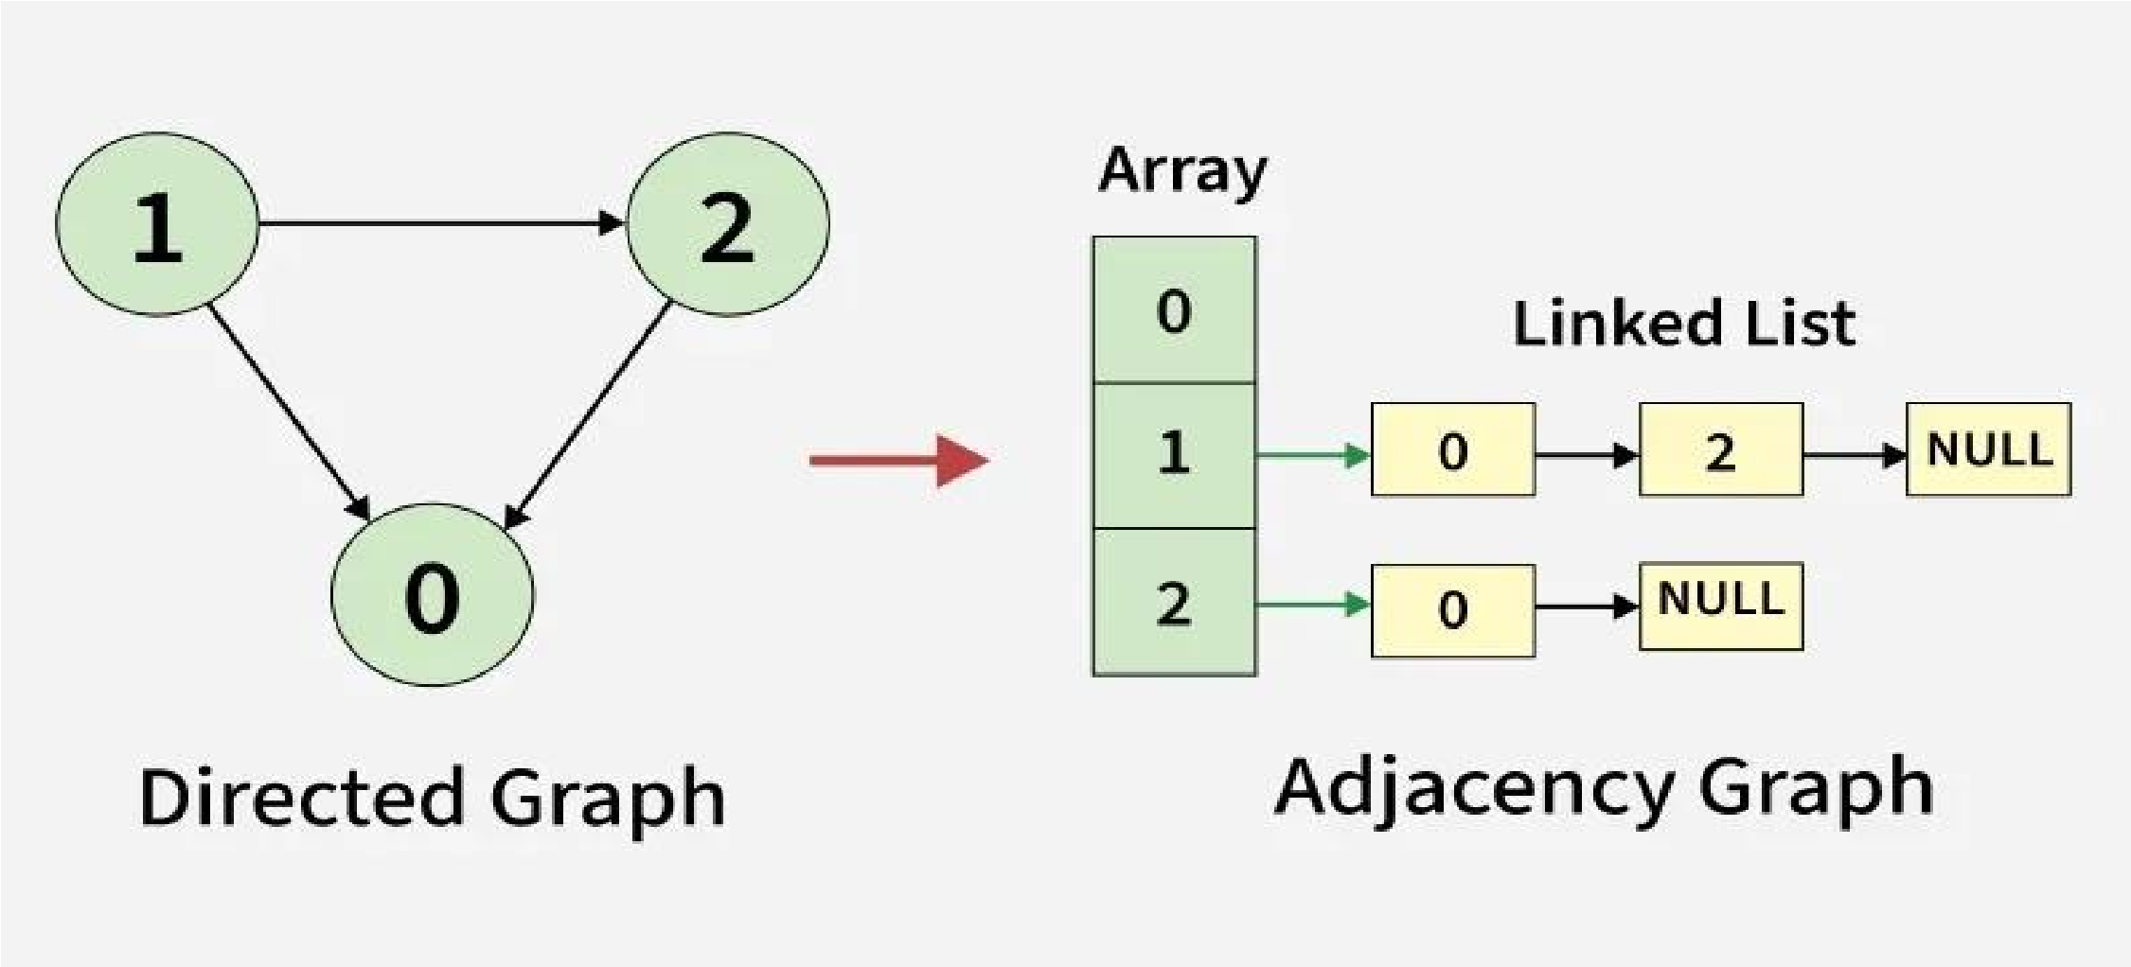
Why use Adjacency List?
Best for sparse graphs
Saves memory
Faster traversal of neighbors
Adjacency List representation
0 → 1 → 2
1 → 0 → 2
2 → 0 → 1 → 3
3 → 2
Each row shows neighbors of that vertex.

Program: Undirected + Unweighted (Simple)
#include <iostream>
#include <vector>
using namespace std;

int main() {
int n, e;
cout << "Enter number of vertices: ";
cin >> n;

vector<int> adj[n];

cout << "Enter number of edges: ";
cin >> e;

cout << "Enter edges (u v):\n";
for (int i = 0; i < e; i++) {
int u, v;
cin >> u >> v;

adj[u].push_back(v);
adj[v].push_back(u); // undirected
}

cout << "\nAdjacency List:\n";
for (int i = 0; i < n; i++) {
cout << i << " → ";
for (int x : adj[i])
cout << x << " ";
cout << endl;
}

return 0;
}

Program: Undirected + Weighted
#include <iostream>
#include <vector>
using namespace std;

int main() {
int n, e;
cin >> n >> e;

vector<pair<int, int>> adj[n];

cout << "Enter edges (u v w):\n";
for (int i = 0; i < e; i++) {
int u, v, w;
cin >> u >> v >> w;

adj[u].push_back({v, w});
adj[v].push_back({u, w}); // undirected weighted
}

cout << "\nAdjacency List (with weights):\n";
for (int i = 0; i < n; i++) {
cout << i << " → ";
for (auto it : adj[i])
cout << "(" << it.first << ", " << it.second << ") ";
cout << endl;
}
}

Program: Undirected + Unweighted (Using Linked List)
#include <stdio.h>
#include <stdlib.h>

struct Node {
int v;
struct Node* next;
};

void addEdge(struct Node* adj[], int u, int v) {
struct Node* node = (struct Node*)malloc(sizeof(struct Node));
node->v = v;
node->next = adj[u];
adj[u] = node;

struct Node* node2 = (struct Node*)malloc(sizeof(struct Node));
node2->v = u;
node2->next = adj[v];
adj[v] = node2;
}

int main() {
int n, e;
printf("Enter vertices: ");
scanf("%d", &n);

struct Node* adj[n];
for (int i = 0; i < n; i++)
adj[i] = NULL;

printf("Enter edges: ");
scanf("%d", &e);

for (int i = 0; i < e; i++) {
int u, v;
scanf("%d %d", &u, &v);
addEdge(adj, u, v);
}

printf("\nAdjacency List:\n");
for (int i = 0; i < n; i++) {
printf("%d → ", i);
struct Node* temp = adj[i];
while (temp != NULL) {
printf("%d ", temp->v);
temp = temp->next;
}
printf("\n");
}
}

What is BFS?
BFS = Level-order traversal of a graph.
It visits all neighbors of a vertex first, then moves forward.
Uses a Queue
Works for graphs and trees
Good for finding shortest path in unweighted graph

BFS Algorithm
1. Create a queue
2. Mark all vertices as unvisited
3. Insert the starting vertex in the queue
4. Mark it as visited
5. While queue is NOT empty:
a. Remove (pop) front element → u
b. Print u
c. For all vertices v:
If adj[u][v] == 1 AND v is not visited:
→ mark visited
→ push v into queue

Example Graph
Vertices = 0,1,2,3
Edges:
0 — 1
0 — 2
1 — 2
2 — 3
Adjacency Matrix:
 | 0 | 1 | 2 | 3
0 | 0 | 1 | 1 | 0
1 | 1 | 0 | 1 | 0
2 | 1 | 1 | 0 | 1
3 | 0 | 0 | 1 | 0
Program for BFS (Adjacency Matrix)
#include <iostream>
#include <queue>
using namespace std;

int main() {
int n;
cin >> n;

int adj[n][n];

// input adjacency matrix
for (int i = 0; i < n; i++)
for (int j = 0; j < n; j++)
cin >> adj[i][j];

int visited[n] = {0};
queue<int> q;

int start;
cout << "Enter starting vertex: ";
cin >> start;

// BFS
visited[start] = 1;
q.push(start);

cout << "BFS Traversal: ";

while (!q.empty()) {
int u = q.front();
q.pop();
cout << u << " ";

for (int v = 0; v < n; v++) {
if (adj[u][v] == 1 && visited[v] == 0) {
visited[v] = 1;
q.push(v);
}
}
}
}

What is DFS?
DFS = Depth-wise traversal.
It goes in depth until no more neighbors, then backtracks.
Uses Stack or Recursion
Good for detecting cycles, connected components, topological sort

DFS Algorithm (Recursive)
DFS(u):
print u
mark u visited

for each vertex v:
if adj[u][v] == 1 AND v not visited:
DFS(v)

Program for DFS (Adjacency Matrix)
#include <iostream>
using namespace std;

void dfs(int u, int n, int adj[][100], int visited[]) {
cout << u << " ";
visited[u] = 1;

for (int v = 0; v < n; v++) {
if (adj[u][v] == 1 && visited[v] == 0) {
dfs(v, n, adj, visited);
}
}
}

int main() {
int n;
cin >> n;

int adj[100][100];

// input adjacency matrix
for (int i = 0; i < n; i++)
for (int j = 0; j < n; j++)
cin >> adj[i][j];

int visited[100] = {0};

int start;
cout << "Enter starting vertex: ";
cin >> start;

cout << "DFS Traversal: ";
dfs(start, n, adj, visited);
}

